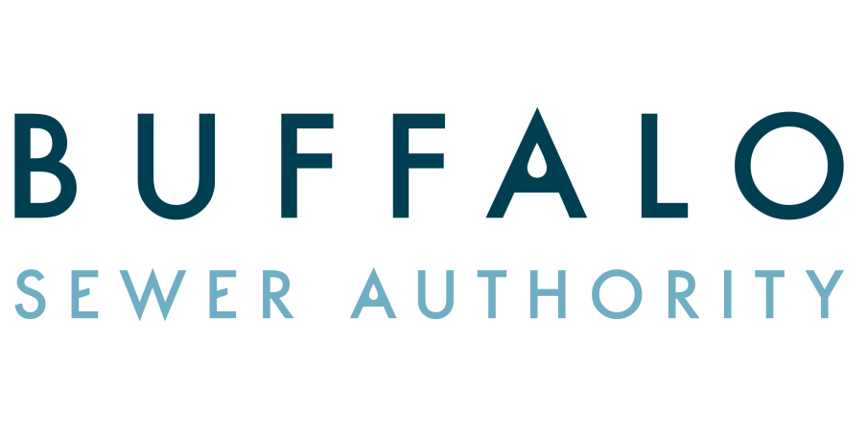

JOB OPENING

Title of Position: Junior Sanitary Engineer
Number of Vacancies: One (1) (Provisional)
Salary Range: $49,418-$59,257
Location: Buffalo Sewer Authority
Buffalo, New York

DUTIES: Drafts and occasionally designs plans and profiles for the construction of minor sanitary sewer and water line projects; Conducts surveys to establish topography and/or geological conditions affecting sewage planning; Supervises the use of and uses engineering instruments in making observations and in gathering and recording engineering data; Supervises and inspects minor construction work on small sewer projects; inspects construction material for conformance to specifications; collects data for computation of quantities and payment to contractors; Supervises the activities of field parties engaged in water pollution surveys; Prepares progress reports; maintains records of work done and changes in plans and specifications; Performs structural design computations and reviews plans of other engineers for errors; Oversees the work of sub-professional engineers and assists with their training; Performs related work as required.
FULL PERFORMANCE KNOWLEDGE, SKILLS, ABILITIES AND PERSONAL CHARACTERISTICS
Good knowledge of the principles, practices and techniques of sanitary engineering; Working knowledge of engineering principles relating to the design, construction and operation of sewers and sewage treatment plant facilities; Working knowledge of the fundamentals of planned development and drafting; ability to make difficult technical computations and to compile engineering data; Skill in the use of engineering field and office instruments; Ability to get along well with others; Ability to read and interpret engineering drawings and specifications; Ability to communicate orally and in writing; Physical condition commensurate with the demands of the position.

Promotional: Applicants must have continuous and permanent status in any city department as a Senior Drafting Technician or Senior Engineering Aide for one year.

REQUIREMENTS
- Bachelors Degree from an accredited college or university in Civil, Environmental, Mechanical or Sanitary Engineering;
OR
- Associates Degree from an accredited junior college or technical institute in Civil or Mechanical Technology and two (2) years of full-time work experience involving the design, construction, development, maintenance or operation of engineering programs or projects;
OR
- Graduation from high school, GED or Equivalency Diploma and four (4) years of full-time experience in Civil, Mechanical, Environmental or Sanitary Engineering where work involves the design, construction, development, maintenance or operation of engineering programs or projects;
OR
- An equivalent combination as defined within the limits of (A) and (C)
All applicants must be a City of Buffalo resident and must apply in writing for this position and specifically detail all experience. This application should be submitted to the: Buffalo Sewer Authority, Attention: Human Resources, 65 Niagara Square/Room 1038 City Hall, Buffalo, NY 14202

